UNITED STATES
SECURITIES AND EXCHANGE COMMISSION
Washington, DC 20549
______________________
SCHEDULE 14A
Proxy Statement Pursuant to Section 14(a) of the
Securities Exchange Act of 1934
(Amendment No.__)
______________________
Filed by the Registrant x
Filed by a Party other than the Registrant o
Check the appropriate box:
o |  |  | Preliminary Proxy Statement
o |  |  | Confidential, For Use of the Commission Only (as permitted by Rule 14a-6(e)(2))
o |  |  | Definitive Proxy Statement
x |  |  | Definitive Additional Materials
o |  |  | Soliciting Material Pursuant to § 240.14a-12
AKAMAI TECHNOLOGIES, INC.
(Name of Registrant as Specified in its Charter)
(Name of Person(s) Filing Proxy Statement, if other than the Registrant)
Payment of Filing Fee (Check all boxes that apply):
x |  |  | No fee required.
o |  |  | Fee paid previously with preliminary materials:
o |  |  | Fee computed on table in exhibit required by Item 25(b) per Exchange Act Rules 14a-6(i)(1) and 0-11.

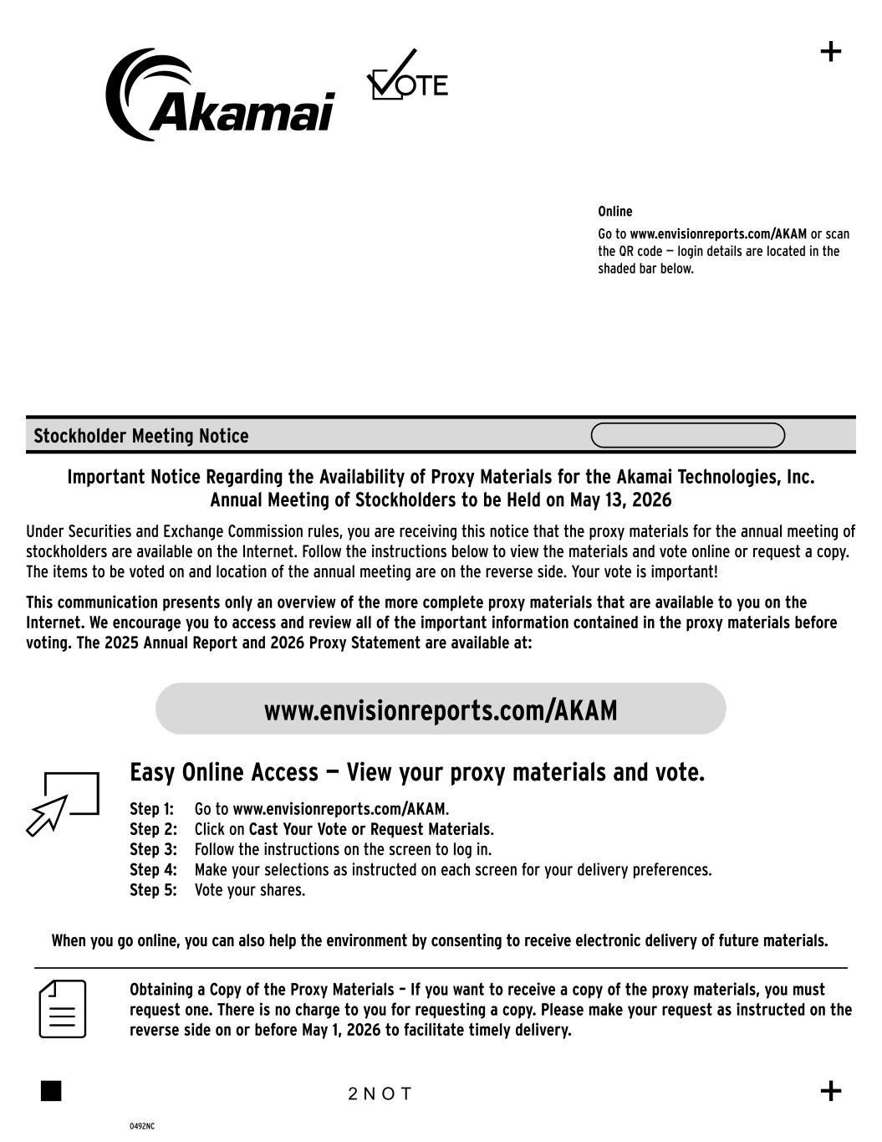

Step 1: Go to www.envisionreports.com/AKAM. Step 2: Click on Cast Your Vote or Request Materials. Step 3: Follow the instructions on the screen to log in. www.envisionreports.com/AKAM Online Go to www.envisionreports.com/AKAM or scan the QR code — login details are located in the shaded bar below. Stockholder Meeting Notice 0492NC Important Notice Regarding the Availability of Proxy Materials for the Akamai Technologies, Inc. Annual Meeting of Stockholders to be Held on May 13, 2026 Under Securities and Exchange Commission rules, you are receiving this notice that the proxy materials for the annual meeting of stockholders are available on the Internet. Follow the instructions below to view the materials and vote online or request a copy. The items to be voted on and location of the annual meeting are on the reverse side. Your vote is important! This communication presents only an overview of the more complete proxy materials that are available to you on the Internet. We encourage you to access and review all of the important information contained in the proxy materials before voting. The 2025 Annual Report and 2026 Proxy Statement are available at: Obtaining a Copy of the Proxy Materials – If you want to receive a copy of the proxy materials, you must request one. There is no charge to you for requesting a copy. Please make your request as instructed on the reverse side on or before May 1, 2026 to facilitate timely delivery. 2 N O T Easy Online Access — View your proxy materials and vote. When you go online, you can also help the environment by consenting to receive electronic delivery of future materials. Step 4: Make your selections as instructed on each screen for your delivery preferences. Step 5: Vote your shares.

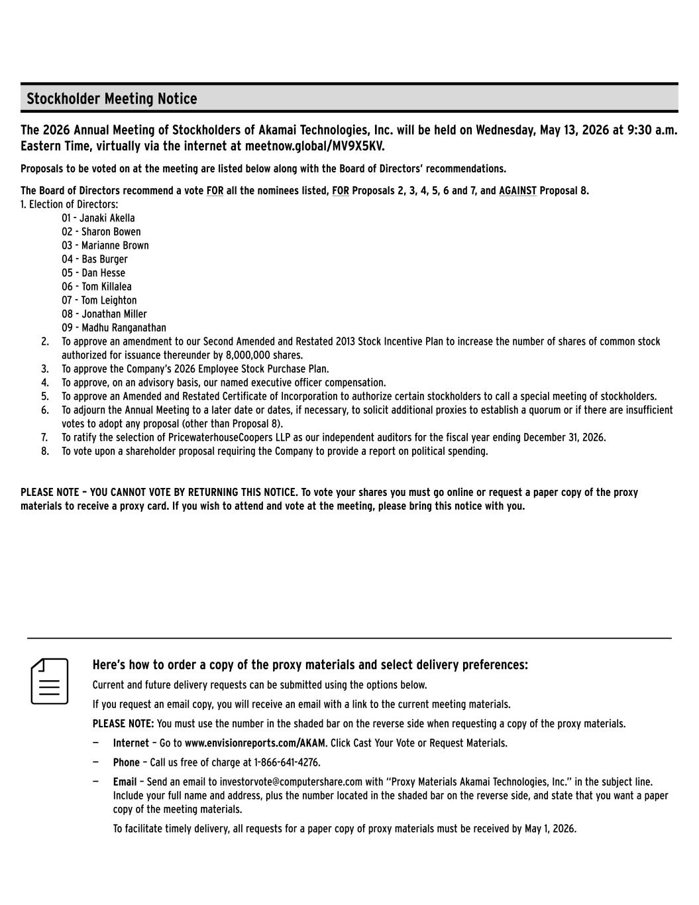
Here’s how to order a copy of the proxy materials and select delivery preferences: Current and future delivery requests can be submitted using the options below. If you request an email copy, you will receive an email with a link to the current meeting materials. PLEASE NOTE: You must use the number in the shaded bar on the reverse side when requesting a copy of the proxy materials. — Internet – Go to www.envisionreports.com/AKAM. Click Cast Your Vote or Request Materials. — Phone – Call us free of charge at 1-866-641-4276. — Email – Send an email to investorvote@computershare.com with “Proxy Materials Akamai Technologies, Inc.” in the subject line. Include your full name and address, plus the number located in the shaded bar on the reverse side, and state that you want a paper copy of the meeting materials. To facilitate timely delivery, all requests for a paper copy of proxy materials must be received by May 1, 2026. The 2026 Annual Meeting of Stockholders of Akamai Technologies, Inc. will be held on Wednesday, May 13, 2026 at 9:30 a.m. Eastern Time, virtually via the internet at meetnow.global/MV9X5KV. Proposals to be voted on at the meeting are listed below along with the Board of Directors’ recommendations. The Board of Directors recommend a vote FOR all the nominees listed, FOR Proposals 2, 3, 4, 5, 6 and 7, and AGAINST Proposal 8. 1. Election of Directors: 01 - Janaki Akella 02 - Sharon Bowen 03 - Marianne Brown 04 - Bas Burger 05 - Dan Hesse 06 - Tom Killalea 07 - Tom Leighton 08 - Jonathan Miller 09 - Madhu Ranganathan 2. To approve an amendment to our Second Amended and Restated 2013 Stock Incentive Plan to increase the number of shares of common stock authorized for issuance thereunder by 8,000,000 shares. 3. To approve the Company’s 2026 Employee Stock Purchase Plan. 4. To approve, on an advisory basis, our named executive officer compensation. 5. To approve an Amended and Restated Certificate of Incorporation to authorize certain stockholders to call a special meeting of stockholders. 6. To adjourn the Annual Meeting to a later date or dates, if necessary, to solicit additional proxies to establish a quorum or if there are insufficient votes to adopt any proposal (other than Proposal 8). 7. To ratify the selection of PricewaterhouseCoopers LLP as our independent auditors for the fiscal year ending December 31, 2026. 8. To vote upon a shareholder proposal requiring the Company to provide a report on political spending. PLEASE NOTE – YOU CANNOT VOTE BY RETURNING THIS NOTICE. To vote your shares you must go online or request a paper copy of the proxy materials to receive a proxy card. If you wish to attend and vote at the meeting, please bring this notice with you. Stockholder Meeting Notice

