SEC Form 4
FORM 4 |  | UNITED STATES SECURITIES AND EXCHANGE COMMISSION  Washington, D.C. 20549  STATEMENT OF CHANGES IN BENEFICIAL OWNERSHIP  Filed pursuant to Section 16(a) of the Securities Exchange Act of 1934  or Section 30(h) of the Investment Company Act of 1940
  OMB APPROVAL
  OMB Number: | 3235-0287
  Estimated average burden
  hours per response: | 0.5
 | Check this box if no longer subject to Section 16. Form 4 or Form 5 obligations may continue. See Instruction 1(b).
1. Name and Address of Reporting Person*  (Street) | 2. Issuer Name and Ticker or Trading Symbol  AKAMAI TECHNOLOGIES INC [ AKAM ] | 5. Relationship of Reporting Person(s) to Issuer  (Check all applicable)
  LEIGHTON F THOMSON
  (Last) | (First) | (Middle)
  C/O AKAMAI TECHNOLOGIES, INC.
  145 BROADWAY
  CAMBRIDGE | MA | 02142
  (City) | (State) | (Zip)
  X | Director |  | 10% Owner
  X | Officer (give title below) |  | Other (specify below)
  Chief Executive Officer
3. Date of Earliest Transaction (Month/Day/Year)
05/01/2023
 | 4. If Amendment, Date of Original Filed (Month/Day/Year) | 6. Individual or Joint/Group Filing (Check Applicable Line)
  X | Form filed by One Reporting Person
   | Form filed by More than One Reporting Person
Table I - Non-Derivative Securities Acquired, Disposed of, or Beneficially Owned
1. Title of Security (Instr. 3) | 2. Transaction Date (Month/Day/Year) | 2A. Deemed Execution Date, if any (Month/Day/Year) | 3. Transaction Code (Instr. 8) |  | 4. Securities Acquired (A) or Disposed Of (D) (Instr. 3, 4 and 5) |  |  | 5. Amount of Securities Beneficially Owned Following Reported Transaction(s) (Instr. 3 and 4) | 6. Ownership Form: Direct (D) or Indirect (I) (Instr. 4) | 7. Nature of Indirect Beneficial Ownership (Instr. 4)
1. Title of Security (Instr. 3) | 2. Transaction Date (Month/Day/Year) | 2A. Deemed Execution Date, if any (Month/Day/Year) | Code | V | Amount | (A) or (D) | Price |  | 6. Ownership Form: Direct (D) or Indirect (I) (Instr. 4) | 7. Nature of Indirect Beneficial Ownership (Instr. 4)
Common Stock | 05/01/2023 |  | P(1) |  | 306 | A | $81.93(2) | 83,799 | D
Common Stock | 05/02/2023 |  | P(1) |  | 313 | A | $79.96(3) | 84,112 | D
Common Stock | 05/03/2023 |  | P(1) |  | 315 | A | $79.44(4) | 84,427 | D
Common Stock |  |  |  |  |  |  |  | 108,358 | I(5) | See note
Common Stock |  |  |  |  |  |  |  | 20,963 | I(6) | See footnote
Common Stock |  |  |  |  |  |  |  | 2,218,134 | I(7) | See note
Table II - Derivative Securities Acquired, Disposed of, or Beneficially Owned
(e.g., puts, calls, warrants, options, convertible securities)
1. Title of Derivative Security (Instr. 3) | 2. Conversion or Exercise Price of Derivative Security | 3. Transaction Date (Month/Day/Year) | 3A. Deemed Execution Date, if any (Month/Day/Year) | 4. Transaction Code (Instr. 8) |  | 5. Number of Derivative Securities Acquired (A) or Disposed of (D) (Instr. 3, 4 and 5) |  | 6. Date Exercisable and Expiration Date (Month/Day/Year) |  | 7. Title and Amount of Securities Underlying Derivative Security (Instr. 3 and 4) |  | 8. Price of Derivative Security (Instr. 5) | 9. Number of derivative Securities Beneficially Owned Following Reported Transaction(s) (Instr. 4) | 10. Ownership Form: Direct (D) or Indirect (I) (Instr. 4) | 11. Nature of Indirect Beneficial Ownership (Instr. 4)
 |  |  |  | Code | V | (A) | (D) | Date Exercisable | Expiration Date | Title | Amount or Number of Shares
Explanation of Responses:
1. Purchase was made pursuant to a Rule 10b5-1 Plan adopted by Mr. Leighton on November 10, 2022.
2. The price reported in Column 4 is a weighted-average price. These shares were purchased in multiple transactions at prices ranging from $81.85 to $81.94, inclusive. The Reporting Person undertakes to provide to the Issuer, any security holder of the Issuer, or the staff of the Securities and Exchange Commission, upon request, full information regarding the number of shares purchased at each separate price within the range set forth in this footnote.
3. The price reported in Column 4 is a weighted-average price. These shares were purchased in multiple transactions at prices ranging from $79.91 to $80.05, inclusive. The Reporting Person undertakes to provide to the Issuer, any security holder of the Issuer, or the staff of the Securities and Exchange Commission, upon request, full information regarding the number of shares purchased at each separate price within the range set forth in this footnote.
4. The price reported in Column 4 is a weighted-average price. These shares were purchased in multiple transactions at prices ranging from $79.21 to $79.46, inclusive. The Reporting Person undertakes to provide to the Issuer, any security holder of the Issuer, or the staff of the Securities and Exchange Commission, upon request, full information regarding the number of shares purchased at each separate price within the range set forth in this footnote.
5. Held by the TBL Foundation of which Mr. Leighton serves as a trustee.
6. Held by the David T. Leighton Trust of which F. Thomson Leighton is a trustee. F. Thomson Leighton disclaims beneficial ownership of shares held by such trust.
7. Held by the F. Thomson Leighton and Bonnie B. Leighton Revocable Trust dtd 11/3/99 of which Mr. Leighton serves as a trustee. Mr. Leighton disclaims beneficial ownership of shares held by such trust except to the extent of his pecuniary interest therein.
Remarks:
EXHIBIT LIST: EX-24 Leighton POA June 2022, GRAPHIC Leighton POA Graphic 2, GRAPHIC Leighton POA Graphic 1
 | /s/ Thomas M. Lair, by power of attorney | 05/03/2023
 | ** Signature of Reporting Person | Date
Reminder: Report on a separate line for each class of securities beneficially owned directly or indirectly.
* If the form is filed by more than one reporting person, see Instruction 4 (b)(v).
** Intentional misstatements or omissions of facts constitute Federal Criminal Violations See 18 U.S.C. 1001 and 15 U.S.C. 78ff(a).
Note: File three copies of this Form, one of which must be manually signed. If space is insufficient, see Instruction 6 for procedure.
Persons who respond to the collection of information contained in this form are not required to respond unless the form displays a currently valid OMB Number.
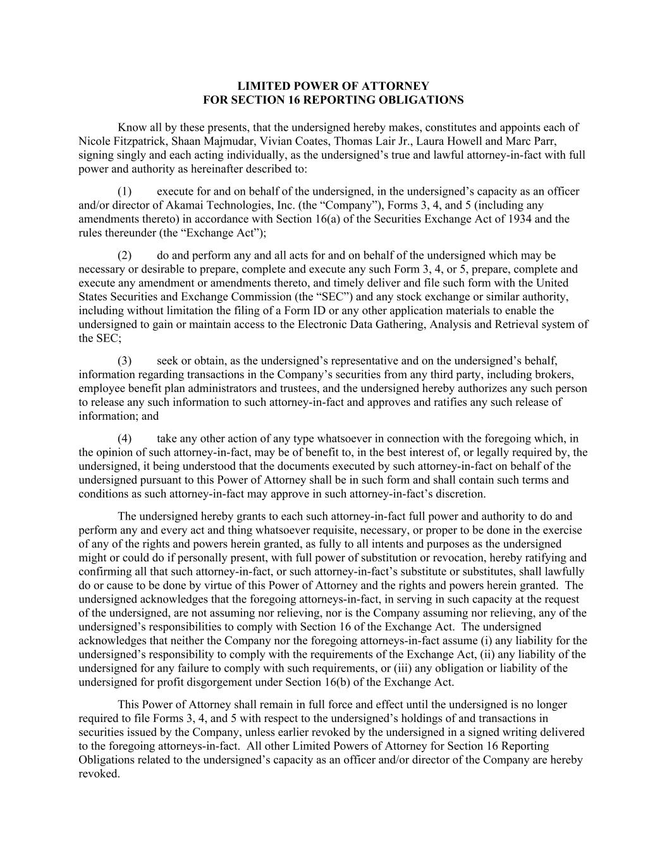
LIMITED POWER OF ATTORNEY FOR SECTION 16 REPORTING OBLIGATIONS Know all by these presents, that the undersigned hereby makes, constitutes and appoints each of Nicole Fitzpatrick, Shaan Majmudar, Vivian Coates, Thomas Lair Jr., Laura Howell and Marc Parr, signing singly and each acting individually, as the undersigned’s true and lawful attorney-in-fact with full power and authority as hereinafter described to: (1) execute for and on behalf of the undersigned, in the undersigned’s capacity as an officer and/or director of Akamai Technologies, Inc. (the “Company”), Forms 3, 4, and 5 (including any amendments thereto) in accordance with Section 16(a) of the Securities Exchange Act of 1934 and the rules thereunder (the “Exchange Act”); (2) do and perform any and all acts for and on behalf of the undersigned which may be necessary or desirable to prepare, complete and execute any such Form 3, 4, or 5, prepare, complete and execute any amendment or amendments thereto, and timely deliver and file such form with the United States Securities and Exchange Commission (the “SEC”) and any stock exchange or similar authority, including without limitation the filing of a Form ID or any other application materials to enable the undersigned to gain or maintain access to the Electronic Data Gathering, Analysis and Retrieval system of the SEC; (3) seek or obtain, as the undersigned’s representative and on the undersigned’s behalf, information regarding transactions in the Company’s securities from any third party, including brokers, employee benefit plan administrators and trustees, and the undersigned hereby authorizes any such person to release any such information to such attorney-in-fact and approves and ratifies any such release of information; and (4) take any other action of any type whatsoever in connection with the foregoing which, in the opinion of such attorney-in-fact, may be of benefit to, in the best interest of, or legally required by, the undersigned, it being understood that the documents executed by such attorney-in-fact on behalf of the undersigned pursuant to this Power of Attorney shall be in such form and shall contain such terms and conditions as such attorney-in-fact may approve in such attorney-in-fact’s discretion. The undersigned hereby grants to each such attorney-in-fact full power and authority to do and perform any and every act and thing whatsoever requisite, necessary, or proper to be done in the exercise of any of the rights and powers herein granted, as fully to all intents and purposes as the undersigned might or could do if personally present, with full power of substitution or revocation, hereby ratifying and confirming all that such attorney-in-fact, or such attorney-in-fact’s substitute or substitutes, shall lawfully do or cause to be done by virtue of this Power of Attorney and the rights and powers herein granted. The undersigned acknowledges that the foregoing attorneys-in-fact, in serving in such capacity at the request of the undersigned, are not assuming nor relieving, nor is the Company assuming nor relieving, any of the undersigned’s responsibilities to comply with Section 16 of the Exchange Act. The undersigned acknowledges that neither the Company nor the foregoing attorneys-in-fact assume (i) any liability for the undersigned’s responsibility to comply with the requirements of the Exchange Act, (ii) any liability of the undersigned for any failure to comply with such requirements, or (iii) any obligation or liability of the undersigned for profit disgorgement under Section 16(b) of the Exchange Act. This Power of Attorney shall remain in full force and effect until the undersigned is no longer required to file Forms 3, 4, and 5 with respect to the undersigned’s holdings of and transactions in securities issued by the Company, unless earlier revoked by the undersigned in a signed writing delivered to the foregoing attorneys-in-fact. All other Limited Powers of Attorney for Section 16 Reporting Obligations related to the undersigned’s capacity as an officer and/or director of the Company are hereby revoked.

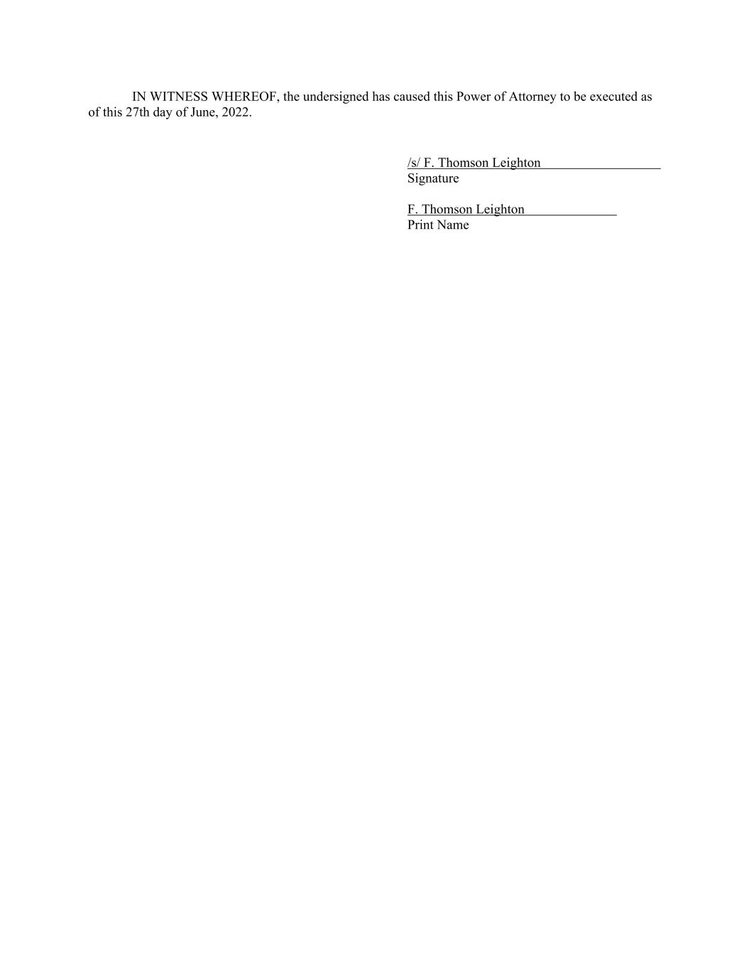
IN WITNESS WHEREOF, the undersigned has caused this Power of Attorney to be executed as of this 27th day of June, 2022. /s/ F. Thomson Leighton Signature F. Thomson Leighton Print Name

